Metronome / Tuner

Custom Project Final Report

Winter 2017

Melissa Santos

Table of Contents

**Introduction** **2**

**Hardware** **2**

Parts List 2

Pinout 3

**Software** **3**

**Complexities** **3**

Completed Complexities: 3

Incomplete complexities: 3

**Youtube Link** **4**

**Known Bugs and Shortcomings** **4**

**Future work** **4**

# 

# Introduction

A metronome is a device used for keeping time. A tuner is used to help correct the intonation of an instrument. It basically tells the user whether the note they played is sharp, flat, or in tune. This project combines both. The project plays tempo and beats specified by the user. The system will also be able to play a tuning note chosen by the user. The system will also tell the user if they are in tune or not.

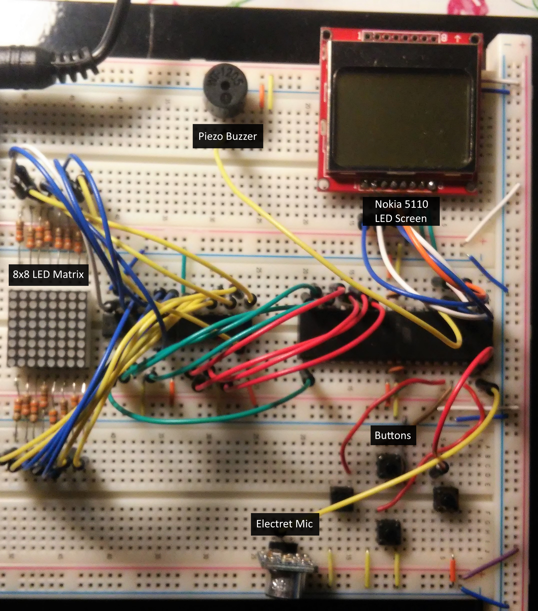

# Hardware

## Parts List

The hardware that was used in this design is listed below. The equipment that was not taught in this course has been bolded.

* ATMega1284p microcontroller
* **8x8 LED Matrix**
* **Electret Microphone**
* Buttons
* **Nokia 5110**
* Piezo Buzzer

## Pinout



# Software



# Complexities

## Completed Complexities:

* Nokia 5110 as a menu display
* Using EEPROM to save the tempo, beat, and note from when it was last on
* LED Matrix used a visual aid for metronome and tuner

## Incomplete complexities:

* Having the electret microphone read the frequency of a note

# Youtube Link

[Link](https://youtu.be/KGUS8g03kyY)

In this video I have rearranged some of the parts so that is it easier to view.

# Known Bugs and Shortcomings

* Major shortcoming is the tuner part of this project. The microphone functions as intended, but the failure is from the software implementation. A FFT was needed in order to translate the analog input from the microphone into a frequency. I could not get a build to compile when using an FFT library in a small project to test the microphone in combination with the FFT library. It is not a major issue seeing as I just needed time to figure out why the library would not compile and adjust it accordingly. This shortcoming could have been avoided if I just moved up date of which I was going to work on FFT.
* Another shortcoming is just the poor implementation of the “matrixDisplay” state machine. There was not enough proper planning for how this state machine was going to act in conjunction with the other states machines. As a result, it is very messy compared to the other machines.
* A small bug is with the LED Matrix when the machine is playing a tempo. When cycling from one pattern to the next, there are strange visual things until that happen until the next click. It can range from the displaying being out of time, to the display showing an incorrect image. The issue comes from me not accounting what happens on the LED matrix when it is cycling between patterns. I believe this bug can be fixed by accounting for those transitions and adjusting the state machine so that it acts accordingly.

# Future work

In the future, I would definitely like to make it so that the tuner functionality of this project works. For the hardware side, I think reducing the buttons and implementing a potentiometer as an input knob would be great. I found that one can only use so many buttons before the design becomes unintuitive. I also would like to try and get this project working on a smaller and cheaper microcontroller so that I can reduce the size. This is because I want to try and design a case for this project and 3D print it. I would like to take it around to my other musician friends and ask their thoughts on the system. For the software side, I want to implement subdivisions in the beats like eighths, triplets, sixteenths, and various syncopated rhythms. I also want to try and make a sight reading sort of game that would be small and brief. Metronomes and tuners are primarily used while warming up, so I think being able to sight read a small excerpt during that period would be very beneficial.